

Scotch College
Semester Two Examination, 2010

Question/Answer Booklet

MATHEMATICS
3C/3D Specialist
Section One:
Calculator free

Teachers Name: HILL / ROBB
(Please Circle)

Name:

Time allowed for this section
Reading time before commencing work: 5 minutes
Working time for this section: 50 minutes

Material required/recommended for this section

To be provided by the supervisor
This Question/Answer Booklet
Formula Sheet

To be provided by the candidate
Standard items: pens, pencils, pencil sharpener, eraser, correction fluid, ruler, highlighters
Special items: nil

Important note to candidates
No other items may be used in this section of the examination. It is your responsibility to ensure that you do not have any unauthorised notes or other items of a non-personal nature in the examination room. If you have any unauthorised material with you, hand it to the supervisor before reading any further.

Structure of this paper

Section | Number of questions available | Number of questions to be answered | Working time (minutes) | Marks  available
Section One:  Calculator-free | 5 | 5 | 50 | 40
Section Two  Calculator-assumed | 11 | 11 | 100 | 80
 |  |  |  | 120

Question | 1 | 2 | 3 | 4 | 5 | Total
Marks | 7 | 9 | 10 | 9 | 5 | 40
Awarded

Instructions to candidates

1. The rules for the conduct of Western Australian external examinations are detailed in the Year 12 Information Handbook 2010. Sitting this examination implies that you agree to abide by these rules.

2. Write your answers in the spaces provided in this Question/Answer Booklet. Spare pages are included at the end of this booklet. They can be used for planning your responses and/or as additional space if required to continue an answer.
  - Planning: If you use the spare pages for planning, indicate this clearly at the top of the page.
  - Continuing an answer: If you need to use the space to continue an answer, indicate in the original answer space where the answer is continued, i.e. give the page number. Fill in the number of the question(s) that you are continuing to answer at the top of the page.

3. Show all your working clearly. Your working should be in sufficient detail to allow your answers to be checked readily and for marks to be awarded for reasoning. Incorrect answers given without supporting reasoning cannot be allocated any marks. For any question or part question worth more than two marks, valid working or justification is required to receive full marks. If you repeat an answer to any question, ensure that you cancel the answer you do not wish to have marked.

4. It is recommended that you do not use pencil except in diagrams.

Section One: Calculator-free (40 Marks)

This section has five (5) questions. Answer all questions. Write your answers in the space provided.
Spare pages are included at the end of this booklet. They can be used for planning your responses and/or as additional space if required to continue an answer.
  - Planning: If you use the spare pages for planning, indicate this clearly at the top of the page.
  - Continuing an answer: If you need to use the space to continue an answer, indicate in the original answer space where the answer is continued, i.e. give the page number. Fill in the number of the question(s) that you are continuing to answer at the top of the page.

Suggested working time for this section is 50 minutes.

1. [7 marks]

Consider the functions 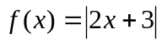 and 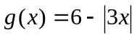

(a) Sketch both functions on the one set of axes below. [4]

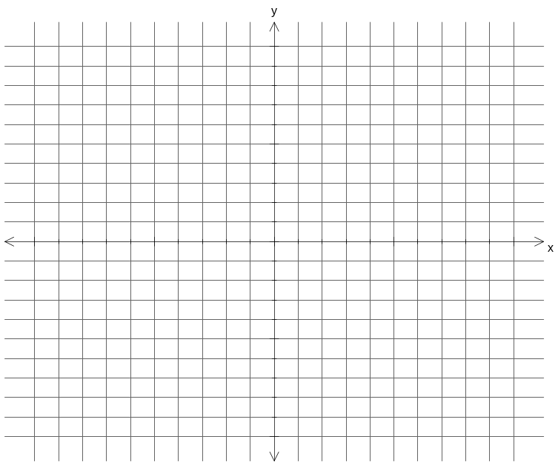

(b) Use algebra to find the x-coordinates of the point(s) of intersection. [3]

2. [9 marks]

(a) Consider the conjecture: 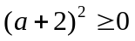

(i) Provide an example that supports this conjecture. [1]

(ii) Provide a counter-example that disproves this conjecture. [1]

(iii) Amend the original conjecture so that is always true. [1]

Question 2 continued...

(b) Use the principal of mathematical induction to prove that:
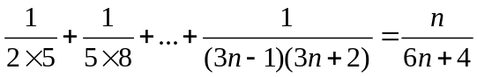 for all n 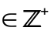 . [6]

3. [10 marks]

(a) Find:
(i) 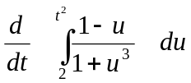 [2]

(ii) 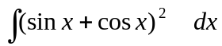 [3]

(b) Use an appropriate substitution to evaluate the integral: [5]
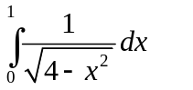 .

4. [9 marks]

If 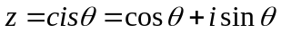 and 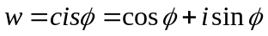, where 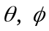 are acute:
(a) Express 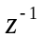 in terms of real and imaginary components. [2]

(b) Show that 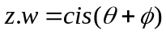 . [3]

(c) Find the modulus and argument of 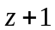 in terms of . [4]
[Hint: Draw a diagram]

5. [5 marks]

(a) 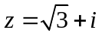 is a point in the complex plane that forms one of the vertices of an equilateral triangle. The triangle is inscribed within a circle of radius 2 units whose centre is the origin. Find the other two vertices of this triangle. [3]

(b) Hence or otherwise, evaluate 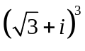. [2]

END OF SECTION ONE
____________________________________________________________________________

Additional working space

Question number(s):

Additional working space

Question number(s):

Additional working space

Question number(s):

Additional working space

Question number(s):

Scotch College
Semester Two Examination, 2010

Question/Answer Booklet

MATHEMATICS
3C/3D Specialist
Section Two:
Calculator-assumed

Teachers Name: HILL / ROBB
(Please Circle)

Name:

Time allowed for this section
Reading time before commencing work: 10 minutes
Working time for this section: 100 minutes

Material required/recommended for this section

To be provided by the supervisor
This Question/Answer Booklet
Formula Sheet (retained from Section One)

To be provided by the candidate
Standard items: pens, pencils, pencil sharpener, eraser, correction fluid, ruler, highlighters

Special items: drawing instruments, templates, notes on two unfolded sheets of A4 paper, and up to three calculators satisfying the conditions set by the Curriculum Council for this examination

Important note to candidates
No other items may be taken into the examination room. It is your responsibility to ensure that you do not have any unauthorised notes or other items of a non-personal nature in the examination room. If you have any unauthorised material with you, hand it to the supervisor before reading any further.

Structure of this paper

Section | Number of questions available | Number of questions to be answered | Working time (minutes) | Marks  available
Section One:  Calculator-free | 5 | 5 | 50 | 40
Section Two  Calculator-assumed | 11 | 11 | 100 | 80
 |  |  |  | 120

Question | 6 | 7 | 8 | 9 | 10 | 11 | 12 | 13 | 14 | 15 | 16 | Total
Marks | 4 | 4 | 10 | 6 | 5 | 7 | 6 | 12 | 8 | 11 | 7 | 80
Awarded

Instructions to candidates

1. Write your answers in the spaces provided in this Question/Answer Booklet. Spare pages are included at the end of this booklet. They can be used for planning your responses and/or as additional space if required to continue an answer.
  - Planning: If you use the spare pages for planning, indicate this clearly at the top of the page.
  - Continuing an answer: If you need to use the space to continue an answer, indicate in the original answer space where the answer is continued, i.e. give the page number. Fill in the number of the question(s) that you are continuing to answer at the top of the page.

2. Show all your working clearly. Your working should be in sufficient detail to allow your answers to be checked readily and for marks to be awarded for reasoning. Incorrect answers given without supporting reasoning cannot be allocated any marks. For any question or part question worth more than two marks, valid working or justification is required to receive full marks. If you repeat an answer to any question, ensure that you cancel the answer you do not wish to have marked.

3. It is recommended that you do not use pencil except in diagrams.

Section Two: Calculator-assumed (80 Marks)

This section has eleven (11) questions. Answer all questions. Write your answers in the space provided.

Spare pages are included at the end of this booklet. They can be used for planning your responses and/or as additional space if required to continue an answer.
  - Planning: If you use the spare pages for planning, indicate this clearly at the top of the page.
  - Continuing an answer: If you need to use the space to continue an answer, indicate in the original answer space where the answer is continued, i.e. give the page number. Fill in the number of the question(s) that you are continuing to answer at the top of the page.

Suggested working time for this section is 100 minutes.

6. [4 marks]

On the Argand diagrams below, plot the locus of z defined by:

(a) 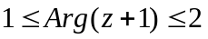 [2]
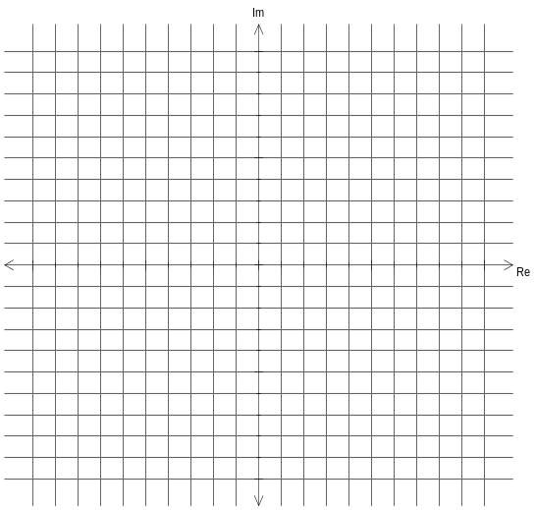

(b) 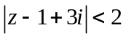 [2]
7. [4 marks]

The distance between the polar co-ordinates 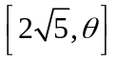and Cartesian co-ordinates 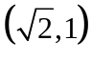 is 5. Find the value of in radians, where 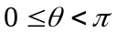.

8. [10 marks]
(a) Find m and n if 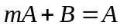, where 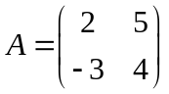 and 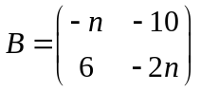 [3]

(b) For what value(s) of k will the matrix 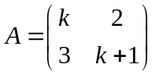 be singular? [3]

Question 8 continued ...

(c) If 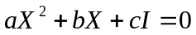 and 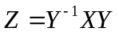, where X, Y and Z are square, non-singular matrices, prove that 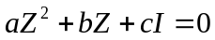. [4]

9. [6 marks]

The table below shows the breeding rates, survival rates and the initial population profile of the population of quokkas on Bald Island.
Age (years) | 0-2 | 2-4 | 4-6 | 6-8 | 8-10
Initial Population | 100 | 150 | 200 | 80 | 40
Breeding Rate | 0 | 1.1 | 0.8 | 0.7 | 0.2
Survival Rate | 0.4 | 0.8 | 0.6 | 0.4 | 0

(a) State the Leslie matrix L for the population of quokkas. [2]

(b) Find the total number of quokkas within the 4th generation. [2]

(c) Determine the approximate long term intergenerational rate of decline.
Explain your answer. [2]

10. [5 marks]

A curve is defined implicitly by: 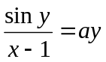 , where a is a constant.
Find the value of the constant a in the curve when 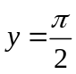 and 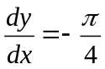 .
Leave your answer as an exact value.

11. [7 marks]

The temperature 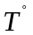C (Celsius) of a gold bar that is left to cool in cold storage is given by the equation 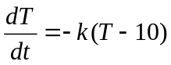 where k is a positive constant and t is time measured in minutes. In the first 10 minutes the temperature falls from 1000 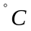 to 600 .

(a) Find the value of k and hence a formula for T in terms of t . [5]

(b) What will be the temperature of the bar after one hour? [1]

(c) How long will it take for the bar to reach 30 ? [1]

12. [6 marks]

A cameraman is asked to film an aircraft flying overhead for a dramatic scene in a movie. The cameraman fixes his camera at ground level and rotates the camera in a vertical arc as the aircraft moves towards him. The aircraft approaches the cameraman flying at a speed of 750 km/h whilst maintaining a constant height of 8000 m above the ground. At what rate is the camera rotating (units in degrees/second) when the horizontal distance of the aircraft is 5 km from the cameraman.

13. [12 marks]

An object exhibits simple harmonic motion such that its displacement, x metres, from a fixed point O on the line after t seconds is given by the equation:

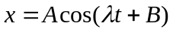

where A, B and λ are positive constants and 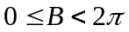.
If v and a are the velocity (m/s) and acceleration (m/s²) respectively, show that

(a) 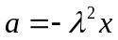 [2]

(b) 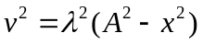 [3]

The object passes through point O for the first time after 1 second and for the second time after 5 seconds, and the maximum distance that the particle moves away from the point O is 8 metres.
(c) Find the values of A, B and λ [4]

Question 13 continued...

(d) When is the first time that the object is furthest away from O? [2]

(e) What is the maximum speed of the object? [1]

14. [8 marks]

Given the function 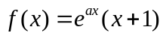, ,

(a) Show that:
(i) 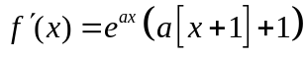 [2]

(ii) 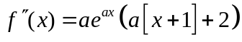 [1]

(b) Show by mathematical induction that 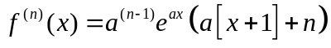, . [5]

15. [11 marks]

Two birds, Eddie and Tweetie, are flying with constant velocities of 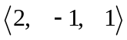 ms⁻¹ and 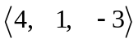 ms⁻¹ respectively. At 10 am Eddie and Tweetie, relative to a birdbath on the ground, are at position vectors of 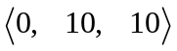m and 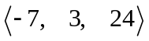 m respectively.

(a) Show that the two birds collide, and give the position at which this occurs. [3]

(b) Give the vector equation of the plane shared by the path of the two birds. [2]

Question 15 continued...

(c) Rocky the cat lies on the ground 20 m from the birdbath and in the same plane shared by the birds. Calculate the position vector of Rocky relative to the birdbath. [6]

16. [7 marks]

The line 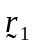is given by the following vector equation : 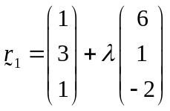
(a) Find the acute angle between the line and the plane 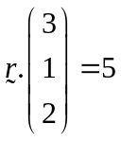 . [3]

(b) Find the shortest distance from a point P(2, -2, 3) to the line . [4]

END OF SECTION TWO
____________________________________________________________________________

Additional working space

Question number(s):

Additional working space

Question number(s):

Additional working space

Question number(s):

Additional working space

Question number(s):

